PIZZA SALES SQL QUERIES

## A.KPI’S

**1.Total Revenue:**

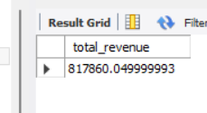

*select sum(total_price) as total_revenue from pizza_sales;*

**2.Average order value**

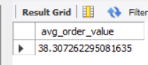

select sum(total_price)/count(distinct order_id) as avg_order_value from pizza_sales;

**3.Total pizza sold**

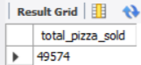

select sum(quantity) as total_pizza_sold from pizza_sales;

**4.Total orders**

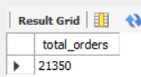

select count(distinct order_id) as total_orders from pizza_sales;

**5.Average pizza per order**

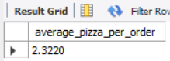

select sum(quantity)/count( distinct order_id) as average_pizza_per_order from pizza_sales;

describe pizza_sales;

ALTER TABLE pizza_sales ADD new_order_date DATE;

UPDATE pizza_sales

SET new_order_date = STR_TO_DATE(order_date, '%d-%m-%Y');

ALTER TABLE pizza_sales DROP COLUMN order_date;

ALTER TABLE pizza_sales CHANGE new_order_date order_date DATE;

ALTER TABLE pizza_sales ADD new_order_time time;

UPDATE pizza_sales set new_order_time = order_time;

UPDATE pizza_sales

SET order_time = STR_TO_DATE(order_time, '%H:%i:%s');

ALTER TABLE pizza_sales MODIFY order_time TIME;

ALTER TABLE pizza_sales DROP COLUMN new_order_time;

## B.CHARTS

**1.Daily trend of total orders**

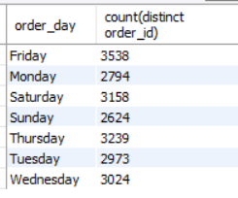

select dayname(order_date) as order_day, count(distinct order_id) from pizza_sales group by dayname(order_date) ;

**2.Monthly trend of total orders**

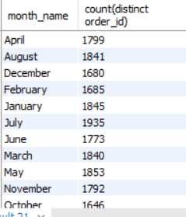

select monthname(order_date) as month_name, count(distinct order_id) from pizza_sales group by monthname(order_date) ;

**3.Percentage of sales by pizza_category**

select pizza_category, sum(total_price)*100/(select sum(total_price) from pizza_sales) AS PCT

from pizza_sales group by pizza_category;

select pizza_category,sum(total_price) AS Total_Sales,sum(total_price)*100/(select sum(total_price) from pizza_sales) AS PCT

from pizza_sales group by pizza_category;

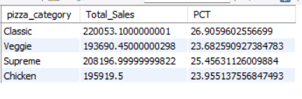

select pizza_category,sum(total_price) AS Total_Sales,sum(total_price)*100/(select sum(total_price) from pizza_sales where month(order_date)=1) AS PCT

from pizza_sales where month(order_date)=1 group by pizza_category;

**4.Percentage of sales by pizza size**

select pizza_size,sum(total_price) AS Total_Sales,cast(sum(total_price)*100/(select sum(total_price) from pizza_sales)AS decimal(10,2)) AS PCT

from pizza_sales group by pizza_size order by PCT asc;

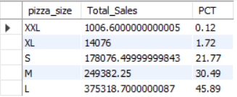

select pizza_size,sum(total_price) AS Total_Sales,cast(sum(total_price)*100/(select sum(total_price) from pizza_sales WHERE quarter(order_date)=1)AS decimal(10,2)) AS PCT

from pizza_sales WHERE quarter(order_date)=1 group by pizza_size

order by PCT asc;

**5.Top 5 Pizzas By Revenue**

select pizza_name,sum(total_price) as Total_Revenue from pizza_sales group by pizza_name

order by Total_Revenue desc limit 5;

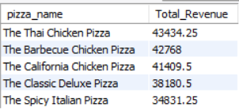

**6.Bottom 5 Pizzas By Revenue**

select pizza_name,sum(total_price) as Total_Revenue from pizza_sales group by pizza_name

order by Total_Revenue asc limit 5;

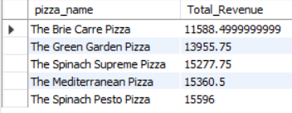

select pizza_name,sum(quantity) as Total_quantity from pizza_sales group by pizza_name

order by Total_quantity asc limit 5;

select pizza_name,count(distinct(order_id)) as Total_orders from pizza_sales group by pizza_name

order by Total_orders desc limit 5;